WMECC111 – Unity Assessment

# Marks Claimed:

* In door of broken dishevelled pirate ship using unity primitives and Probuilder (25%)
* Outdoor section made with terrain editor, including rock texture, trees and water (25%)
* Floor board material/texture on indoor section (5%)
* Use of emissive materials (5%)
* Particle Systems (10%)
* Use of multiple cameras, first person controller and mini map (10%)
* Trigger door and mouse event door (10%)
* Post processing stack
* Use of NavMeshAgents, patrol and chase (10%)

# The Pirate Ship

The pirate ship has both a click door and a trigger door. It also has textured floors, walls, door and ceiling.

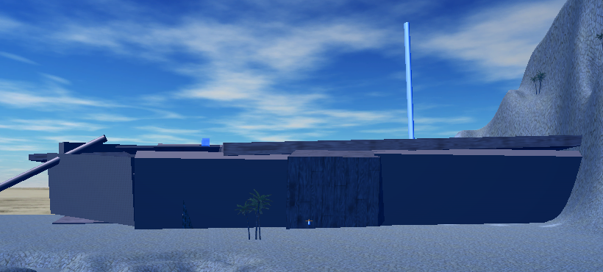

# Terrain

I created a rocky ocean floor terrain. I also used a sand and sky skybox. The waters is spaced out and shallow as the aim of the game is to raise water levels which will happen with progression.

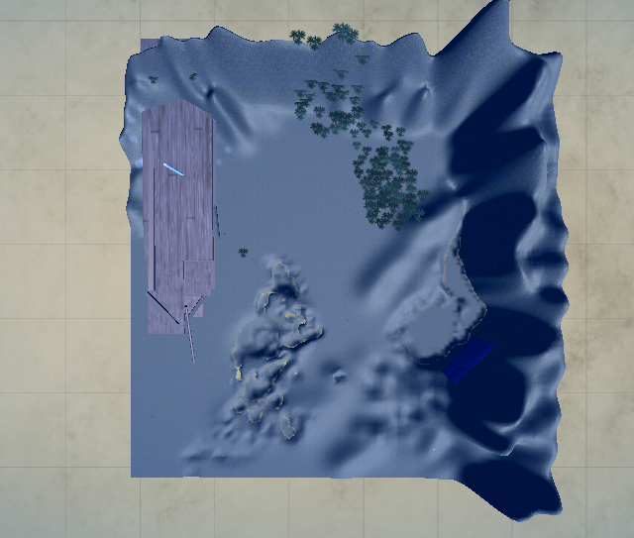

# 

# Waterfall

The waterfall has a quad with a unique material on it. The quad has an image of water and is ambient blue. There is also a particle system to look like a water fall. I edited the start sizes, lifetime, emission, shape and renderer in order to have the particles waterlike being different sizes and turning particles to look more realistic. The waterfall falls into a water base.

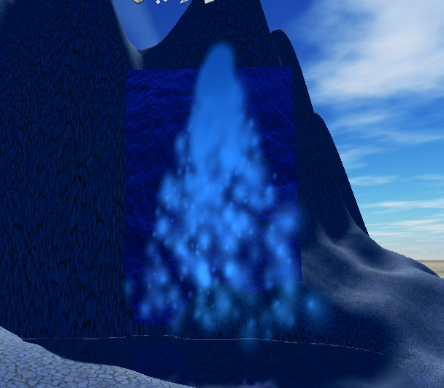

# 

# Characters

I have both a patrol enemy and following character. The patrol enemy is meant to represent an angry pirate who is the antagonist of this level. The Following character is a friendly helpful asset. Both have scripts and Nav mesh.

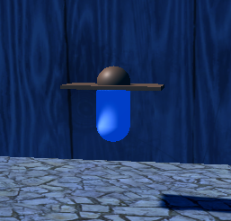

# Challenges and Changes

I did struggle with certain aspects of game creation as I had no experience in comparison to other people. I would have liked to add some more aesthetics, but also since the ocean is drained to many are not necessary. I am proud of my waterfall as I think the particle system looks good.

# Assets Used

SkyBox 8K

WoodFLoor